**College Management Feedback**

|  |  |
| --- | --- |
| **CONTENT** | **PAGE NO** |
| **Abstract** |  |
| **1.INTRODUCTION** |  |
| 1.1 Motivation |  |
| 1.2 Problem Statement |  |
| 1.3 Objective of the Project |  |
| 1.4 Scope |  |
| 1.5 Project Introduction |  |
| **2.LITERATURE SURVEY** |  |
| 2.1 Related Work |  |
| **3. SYSTEM ANALYSIS** |  |
| 3.1 Existing System |  |
| 3.2 Disadvantages |  |
| 3.3 Proposed System |  |
| 3.4 Advantages |  |
| 3.5 work Flow of Proposed system |  |
| **4. REQUIREMENT ANALYSIS** |  |
| 4.1Function and non-functional requirements |  |
| 4.2 Hardware Requirements |  |
| 4.3 Software Requirements |  |
| 4.4 Architecture |  |
| **5. SYSTEM DESIGN** |  |
| 5.1 Introduction of Input design |  |
| 5.2 UML Diagram(class, use case, sequence, collaborative, deployment, |  |
| 5.3 Data Flow Diagram |  |
| **6. IMPLEMENTATION AND RESULTS** |  |
| 6.1 Modules |  |
| 6.2 Output Screens |  |
| 1. **JAVA ENVIRONMENT** |  |
| 7.1 Software Installation |  |
| 7.2 About Java Language |  |
| 1. **SYSTEM STUDY AND TESTING** |  |
| 8.1 Feasibility study |  |
| 8.2 Types of test |  |
| **9. CONCLUSION** |  |
| **10. FUTURE ENHANCEMENT** |  |
| **11. REFERENCES** |  |

**ABSTRACT:**

The employee dashboard is a comprehensive digital interface designed to enhance the efficiency, productivity, and engagement of a workforce within an organization. Serving as a centralized hub, the dashboard amalgamates critical information and tools relevant to employees, providing a real-time overview of key performance metrics, task assignments, upcoming events, and personalized updates. Through its user-friendly design and customizable features, the dashboard empowers employees to efficiently manage their tasks, track their progress, collaborate with colleagues, and access essential resources. Additionally, data visualization tools offer insights into individual and team performance trends, enabling informed decision-making at various organizational levels. By fostering transparency, communication, and data-driven insights, the employee dashboard optimizes workflow, bolsters employee satisfaction, and contributes to the overall success of the organization. This abstract encapsulates the multifaceted benefits and functionalities of the employee dashboard, highlighting its pivotal role in modern workforce management and organizational dynamics. Online platform that facilitates the collection and analysis of feedback from students, faculty, and staff in a college or university setting

**Keywords:** Employee , Subject ,Student , Feedback , Hod , etc

1. **INTRODUCTION**

**1.1 Motivation:**

Now a days faculty who are giving lecture in classes don’t know how student were feeling about hos class. If faculty want feedbacks, he can ask directly to the students but whenever directly asking feedbacks will come from students not properly. Here in this project student can give feedback in online directly particular faculty.

**1.2 Problem Statement:**

Employee dashboard is software developed for getting feedbacks from students. It facilitates to access the feedback information of a particular faculty . By just a click on the mouse, the system will be able to produce the feedback report thus reducing the need for asking student manually in the class .

**1.3 Objective of the Project:**

The objective of the project –College Management Feedback application is as follows:

**“Employee dashboard”** is software developed for maintaining the feedback information from students. The objective of Employee dashboard system is to provide a user-friendly and efficient platform that enables faculty to access relevant and up-to-date information about their feedback details, check the details by individually which subject getting good feedback.

**1.4 Scope:**

The scope of the project is the system on which the software is installed, i.e, the project is developed as a desktop application. Overall, the scope of Employee dashboard systems can be quite extensive, and they can provide significant benefits to feedback information ,date of the particular day and subject details.

**1.5 Project Introduction:**

In today's fast-paced and dynamic work environment, organizations are continually seeking innovative ways to streamline operations, enhance collaboration, and empower their workforce. One such solution that has gained significant traction is the implementation of an employee dashboard. The employee dashboard serves as a digital cockpit, providing employees with a consolidated and user-friendly platform to access crucial information, monitor performance metrics, manage tasks, and engage with their colleagues.

As businesses grow and adapt to changing market landscapes, the need for efficient communication, data-driven insights, and seamless task management becomes paramount. Traditional methods of disseminating information and managing tasks often lead to fragmentation and inefficiencies, hindering both individual productivity and overall team cohesion. The employee dashboard addresses these challenges by centralizing essential data, tools, and resources in a single, accessible location.

This project aims to develop and implement an advanced employee dashboard tailored to the unique needs of our organization. By leveraging cutting-edge technologies and intuitive design principles, the dashboard will revolutionize how our employees interact with information, collaborate with team members, and track their progress. This project holds the potential to not only boost operational efficiency and employee satisfaction but also contribute to informed decision-making by providing real-time insights into performance trends and key metrics.

Throughout this project, we will delve into the intricate process of designing, developing, and deploying an employee dashboard that aligns seamlessly with our organizational goals. From user experience design to data integration and security considerations, every aspect will be meticulously addressed to ensure a robust and effective solution. By embarking on this journey, we are investing in the transformation of our work culture, fostering transparency, accountability, and collaboration.

In the subsequent sections of this project, we will explore the key features, technical components, and anticipated benefits of the employee dashboard. We will also delve into the implementation strategy, potential challenges, and the roadmap for successful adoption. Through this comprehensive approach, we aim to set the stage for a successful employee dashboard implementation that will elevate our organization's operational prowess and elevate the employee experience to unprecedented heights.

1. **LITERATURE SURVEY**

**2.1 Related Work:**

**[1]** **C. Emery, Tracy R. Kramer and Robert G. Tian, Return to academics standards: a critique of student evaluations of teaching effectiveness, Quality Assurance in Education, vol. II, no. 1, pp. 37-46, 2003.**

A student evaluation of teaching effectiveness (SETE) is often the most influential information in promotion and tenure decision at colleges and universities focused on teaching. Unfortunately, this instrument often fails to capture the lecturer’s ability to foster the creation of learning and to serve as a tool for improving instruction. In fact, it often serves as a disincentive to introducing rigour. This paper performs a qualitative (e.g. case studies) and quantitative (e.g. empirical research) literature review of student evaluations as a measure of teaching effectiveness. Problems are highlighted and suggestions offered to improve SETEs and to refocus teaching effectiveness on outcome-based academic standards..

**[2] J. T. E. Richardson, "Instruments for obtaining student feedback: a review of the literature", Assessment & Evaluation in Higher Education, vol. 30, no. 4, pp. 387-415, 2005.**

This paper reviews the research evidence concerning the use of formal instruments to measure students’ evaluations of their teachers, students’ satisfaction with their programmes and students’ perceptions of the quality of their programmes. These questionnaires can provide important evidence for assessing the quality of teaching, for supporting attempts to improve the quality of teaching and for informing prospective students about the quality of course units and programmes. The paper concludes by discussing several issues affecting the practical utility of the instruments that can be used to obtain student feedback. Many students and teachers believe that student feedback is useful and informative, but for a number of reasons many teachers and institutions do not take student feedback sufficiently seriously.

**[3]**  **A. M. Zapalska, M. N. Bugaj, F. Flanegin and D. Rudd, "Student feedback on distance learning with the use of WebCT", Computers in Higher Education Economics Review, vol. 16, no. 1, pp. 10-14, 2004.**

This paper argues that pedagogical improvement can be successfully achieved by using technology. The use of WebCT-based instruction in an Economics undergraduate distance-learning programme is one vivid demonstration of the potential for using technology in instruction. Here, a satellite Economics course is taught using the WebCT as a complementary teaching instrument. This paper shows that using WebCT strongly contributed to the effectiveness of distance learning by improving the quality of students' comprehension in areas of critical thinking, problem solving, decision-making ability, aptitude for detail, written communication, knowledge of information, and ability to organise and analyse.

**[4] T. Zarraonandia, P. Díaz, Á. Montero, I. Aedo and T. Onorati, "Using a Google Glass-based Classroom Feedback System to improve students to teacher communication", IEEE Access, vol. 7, pp. 16837-16846, 2019.**

In this paper, The use of augmented reality (AR) to support the learning process has been extensively researched but its use to support the teaching practice has just started to be explored. In this paper, we present a communication system that makes use of a pair of Google Glass to provide the teacher with a constant and private flow of information on the students&#39; current knowledge. The proposed system allows the information sent by the students through their mobiles to overlap with the teachers&#39; live vision of the class. Compared to other feedback systems like clickers or backchannel systems, this AR prototype avoids teachers diverting their gaze and interrupting the class to access the students&#39; feedback. This supports the constant monitoring of potential comprehension problems that might otherwise be overlooked. With the aim of obtaining insights on the teachers&#39; and students&#39; views of the system, we conducted two studies during which the system was used in real classroom settings. The results of both studies suggest that the AR system could report benefits in terms of better communication between students and teachers, and a more adequate rhythm of the class. Also, the use of the AR system in the classroom does not necessarily constitute an element, which will distract and disrupt educational activity

**[5] V. Rivera-Pelayo, J. Munk, V. Zacharias and S. Braun, "Live interest meter: learning from quantified feedback in mass lectures", Proceedings of the Third International Conference on Learning Analytics and Knowledge, pp. 23-27, 2013.**

In this paper, There is currently little or no support for speakers to learn by reflection when addressing a big audience, like mass lectures, virtual courses or conferences. Reliable feedback from the audience could improve personal skills and work performance. To address this shortcoming we have developed the Live Interest Meter App (LIM App) that supports the gathering, aggregation and visualization of feedback. This application allows audience members to easily provide and quantify their feedback through a simple meter. We conducted several experimental tests to investigate the acceptance and perceived usefulness of the LIM App and a user study in an academic setting to inform its further development. The results of the study illustriate the potential of the LIM App to be used in such scenarios. Main findings show the need for motivating students to use the application, the readiness of presenters to learn retrospectively, and distraction as the main concern of end users.

**[6] R. Anderson, T. VanDeGrift, S. A. Wolfman, K. Yasuhara and R. Anderson, "Interaction patterns with a classroom feedback system: making time for feedback" in CHI’03 Extended Abstracts on Human Factors in Computing Systems, pp. 880-881, 2003..**

In this paper, we describe two novel patterns of interaction that arose in a study of a computer-mediated feedback system for the university classroom. In both patterns, students gave feedback through the system that they would not have given aloud for lack of an appropriate moment— either because the feedback would be premature or tardy. We describe the patterns themselves and how awareness of the patterns can inform pedagogy and system-building.

**3. SYSTEM ANALYSIS**

**3.1 Existing System**

Previously the college management used to take feedback on paper. The process is as follows o Approaching students of each section. o Distributing feedback forms of every faculty to each student. o Collecting the forms after students fill them. o Sorting of the forms according to Subject. o Accessing each faculty.

**3.2** **Disadvantages**

o It is time consuming.

o It needs lot of human effort.

o More time for accessing.

o Possibility of proxies.

o Possibility for human errors.

**3.3 Proposed System**

In this new system we have provided a website where each student can give there feedback about their faculty and still their names kept unrevealed. This is done in this manner.

**3.4 Advantages**

o Easy interface for the administrator to work on.

o Easy access to students.

o Generating reports instantly.

o Less time consuming process.

o Less human errors and proxies.

**3.5 work Flow of Proposed system**

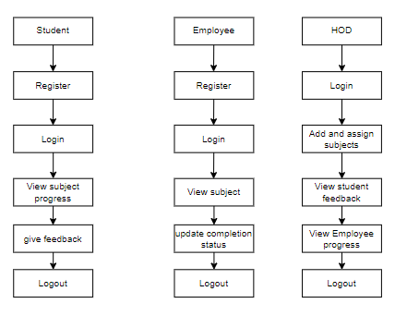

**4. REQUIREMENT ANALYSIS**

**4.1 Functional and non-functional requirements**

Requirement’s analysis is very critical process that enables the success of a system or software project to be assessed. Requirements are generally split into two types: Functional and non-functional requirements.

**Functional Requirements**: These are the requirements that the end user specifically demands as basic facilities that the system should offer. All these functionalities need to be necessarily incorporated into the system as a part of the contract. These are represented or stated in the form of input to be given to the system, the operation performed and the output expected. They are basically the requirements stated by the user which one can see directly in the final product, unlike the non-functional requirements.

Examples of functional requirements:

1. Authentication of user whenever he/she logs into the system
2. System shutdown in case of a cyber-attack
3. A verification email is sent to user whenever he/she register for the first time on some software system.

**Non-functional requirements**: These are basically the quality constraints that the system must satisfy according to the project contract. The priority or extent to which these factors are implemented varies from one project to other. They are also called non-behavioral requirements.  
They basically deal with issues like:

* Portability
* Security
* Maintainability
* Reliability
* Scalability
* Performance
* Reusability
* Flexibility

Examples of non-functional requirements:

1. Emails should be sent with a latency of no greater than 12 hours from such an activity.
2. The processing of each request should be done within 10 seconds
3. The site should load in 3 seconds whenever of simultaneous users are > 10000
   1. **Hardware Requirements**

# Processor - I3/Intel Processor

Hard Disk - 160GB

Key Board - Standard Windows Keyboard

Mouse - Two or Three Button Mouse

Monitor - SVGA

RAM - 8GB

* 1. **Software Requirements:**

Operating System : Windows 7/8/10

Server side Script : HTML,CSS,JS

Programming Language : Java

IDE/Workbench : Intellij Idea

Technology : Java 1.8

Server : Tomcat Server

Database : MySQL

* 1. **Architecture:**

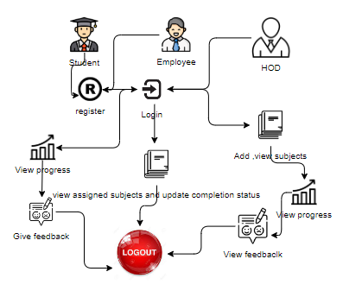

**5. SYSTEM DESIGN**

**5.1 Introduction of Input Design:**

In an information system, input is the raw data that is processed to produce output. During the input design, the developers must consider the input devices such as PC, MICR, OMR, etc.

Therefore, the quality of system input determines the quality of system output. Well-designed input forms and screens have following properties −

* It should serve specific purpose effectively such as storing, recording, and retrieving the information.
* It ensures proper completion with accuracy.
* It should be easy to fill and straightforward.
* It should focus on user’s attention, consistency, and simplicity.
* All these objectives are obtained using the knowledge of basic design principles regarding −
  + What are the inputs needed for the system?
  + How end users respond to different elements of forms and screens.

### **Objectives for Input Design:**

The objectives of input design are −

* To design data entry and input procedures
* To reduce input volume
* To design source documents for data capture or devise other data capture methods
* To design input data records, data entry screens, user interface screens, etc.
* To use validation checks and develop effective input controls.

**Output Design:**

The design of output is the most important task of any system. During output design, developers identify the type of outputs needed, and consider the necessary output controls and prototype report layouts.

### Objectives of Output Design:

The objectives of input design are:

* To develop output design that serves the intended purpose and eliminates the production of unwanted output.
* To develop the output design that meets the end user’s requirements.
* To deliver the appropriate quantity of output.
* To form the output in appropriate format and direct it to the right person.
* To make the output available on time for making good decisions.

**5.2 UML Diagrams:**

**5.2.1 Use Case Diagram:**

A use case diagram in the Unified Modeling Language (UML) is a type of behavioral diagram defined by and created from a Use-case analysis. Its purpose is to present a graphical overview of the functionality provided by a system in terms of actors, their goals (represented as use cases), and any dependencies between those use cases. The main purpose of a use case diagram is to show what system functions are performed for which actor. Roles of the actors in the system can be depicted.

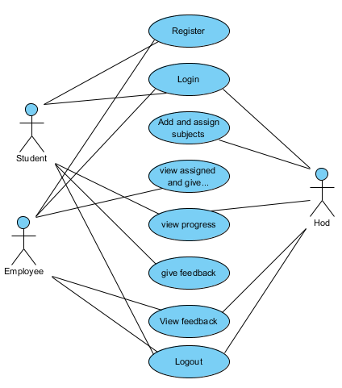

**5.2.2 Class Diagram:**

In software engineering, a class diagram in the Unified Modelling Language (UML) is a type of static structure diagram that describes the structure of a system by showing the system's classes, their attributes, operations (or methods), and the relationships among the classes. It explains which class contains information.

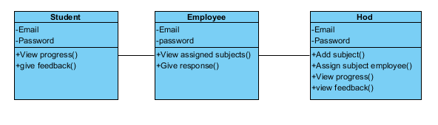

**5.2.3 Sequence Diagram:**

A sequence diagram in Unified Modelling Language (UML) is a kind of interaction diagram that shows how processes operate with one another and in what order. It is a construct of a Message Sequence Chart. Sequence diagrams are sometimes called event diagrams, event scenarios, and timing diagrams.

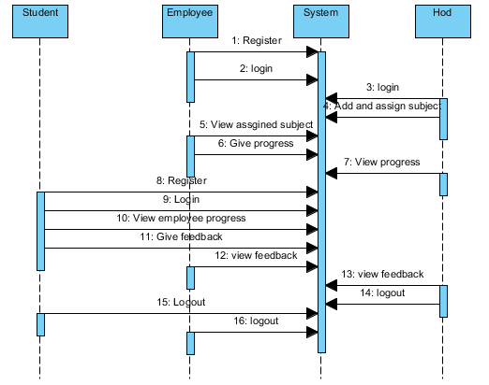

**5.2.4 Collaboration Diagram:**

In collaboration diagram the method call sequence is indicated by some numbering technique as shown below. The number indicates how the methods are called one after another. We have taken the same order management system to describe the collaboration diagram. The method calls are similar to that of a sequence diagram. But the difference is that the sequence diagram does not describe the object organization whereas the collaboration diagram shows the object organization.

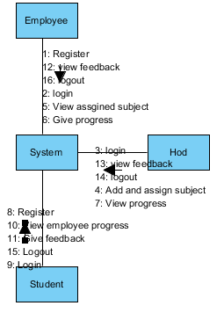

**5.2.5 Deployment Diagram**

Deployment diagram represents the deployment view of a system. It is related to the component diagram. Because the components are deployed using the deployment diagrams. A deployment diagram consists of nodes. Nodes are nothing but physical hardware’s used to deploy the application.

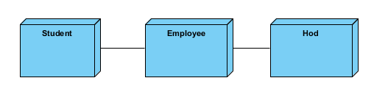

**5.2.6 Activity Diagram:**

Activity diagrams are graphical representations of workflows of stepwise activities and actions with support for choice, iteration and concurrency. In the Unified Modelling Language, activity diagrams can be used to describe the business and operational step-by-step workflows of components in a system. An activity diagram shows the overall flow of control.

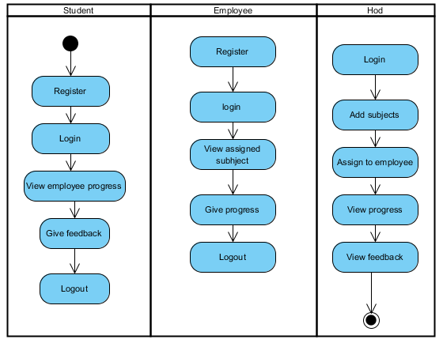

**5.2.7 Component Diagram**:

A component diagram, also known as a UML component diagram, describes the organization and wiring of the physical **c**omponents in a system. Component diagrams are often drawn to help model implementation details and double-check that every aspect of the system's required functions is covered by planned development.

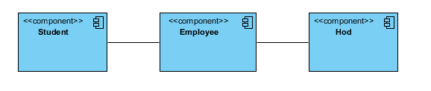

**5.2.8 ER Diagram:**

An Entity–relationship model (ER model) describes the structure of a database with the help of a diagram, which is known as Entity Relationship Diagram (ER Diagram). An ER model is a design or blueprint of a database that can later be implemented as a database. The main components of E-R model are: entity set and relationship set.

An ER diagram shows the relationship among entity sets. An entity set is a group of similar entities and these entities can have attributes. In terms of DBMS, an entity is a table or attribute of a table in database, so by showing relationship among tables and their attributes, ER diagram shows the complete logical structure of a database. Let’s have a look at a simple ER diagram to understand this concept.

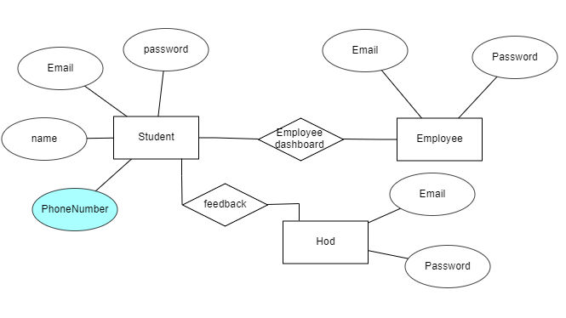

**5.3 DFD Diagram:**

A Data Flow Diagram (DFD) is a traditional way to visualize the information flows within a system. A neat and clear DFD can depict a good amount of the system requirements graphically. It can be manual, automated, or a combination of both. It shows how information enters and leaves the system, what changes the information and where information is stored. The purpose of a DFD is to show the scope and boundaries of a system as a whole. It may be used as a communications tool between a systems analyst and any person who plays a part in the system that acts as the starting point for redesigning a system.

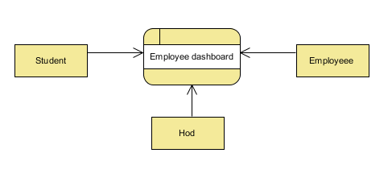

**Level 1 Diagram:**

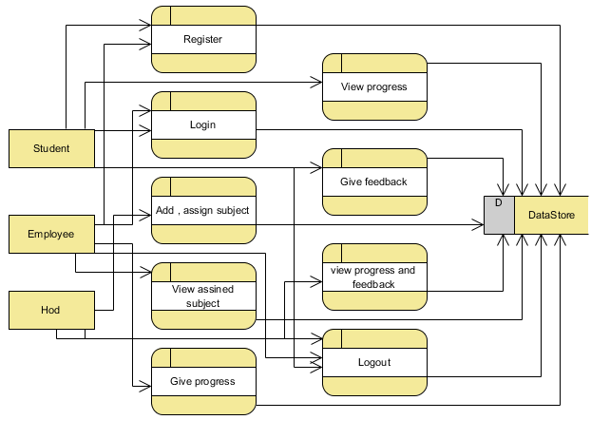

**Level 2 Diagram:**

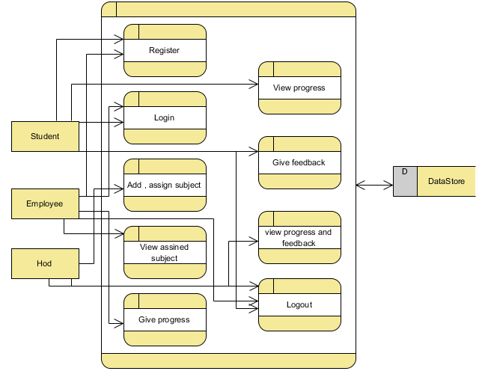

**IMPLEMENTATION AND RESULTS**

**6.1 Modules:**

In this application involved Two characters to implement this process they are Faculty, Student, Hod.

**Faculty :** Faculty is person to give completed percentage.

**Register:** Faculty will register into the application by entering the valid details like (username and password and etc).

**Login:** faculty will login into the application by entering the valid details like (username and password).

Operation- **Give response :**  Update subject completion status.

**View Feedback:**  Faculty can view feedbacks from student .

**Hod :** Hod is person to assign subjects to the faculty.

Operation-**Login:** hod will login into the application by entering the valid details like (hod@gmail.com and hod).

**Add subject and assign :** Hod can add subjects and assign to a particular faculty.

**View Feedback and Employee progress:**  After assign faculty hod can view his class details, student feedback.

**6.2 Results:**

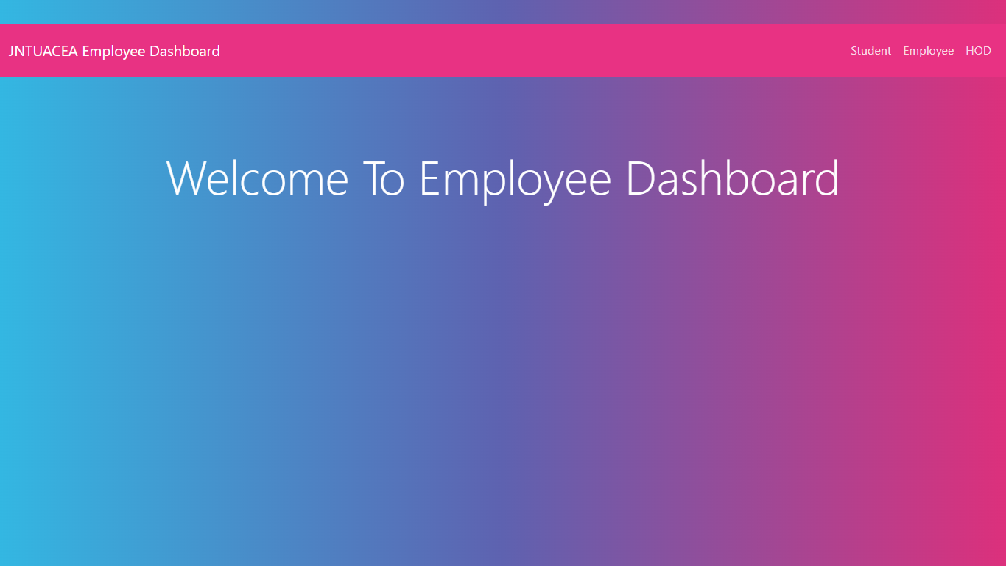

**Home:** This is the home page.

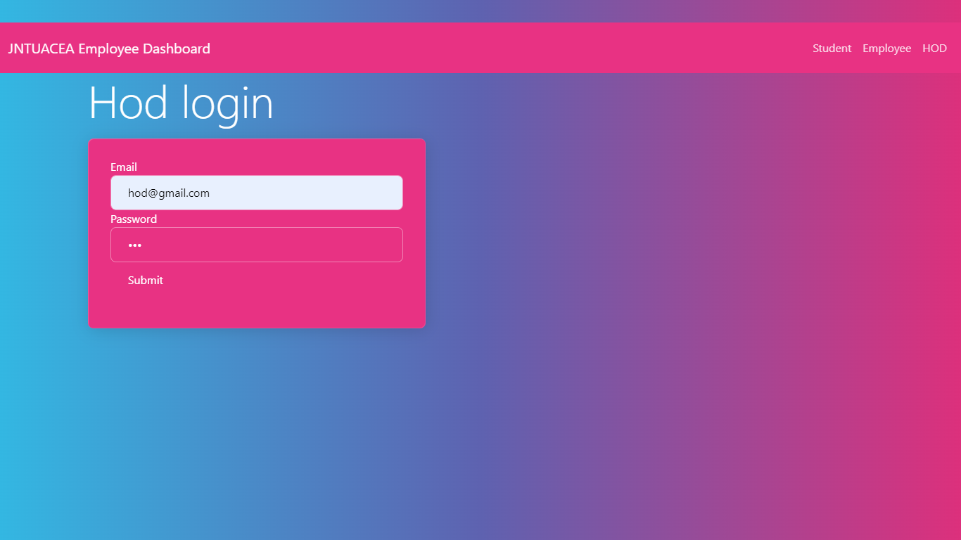

**HOD:** Hod can login with these page with default credentials.

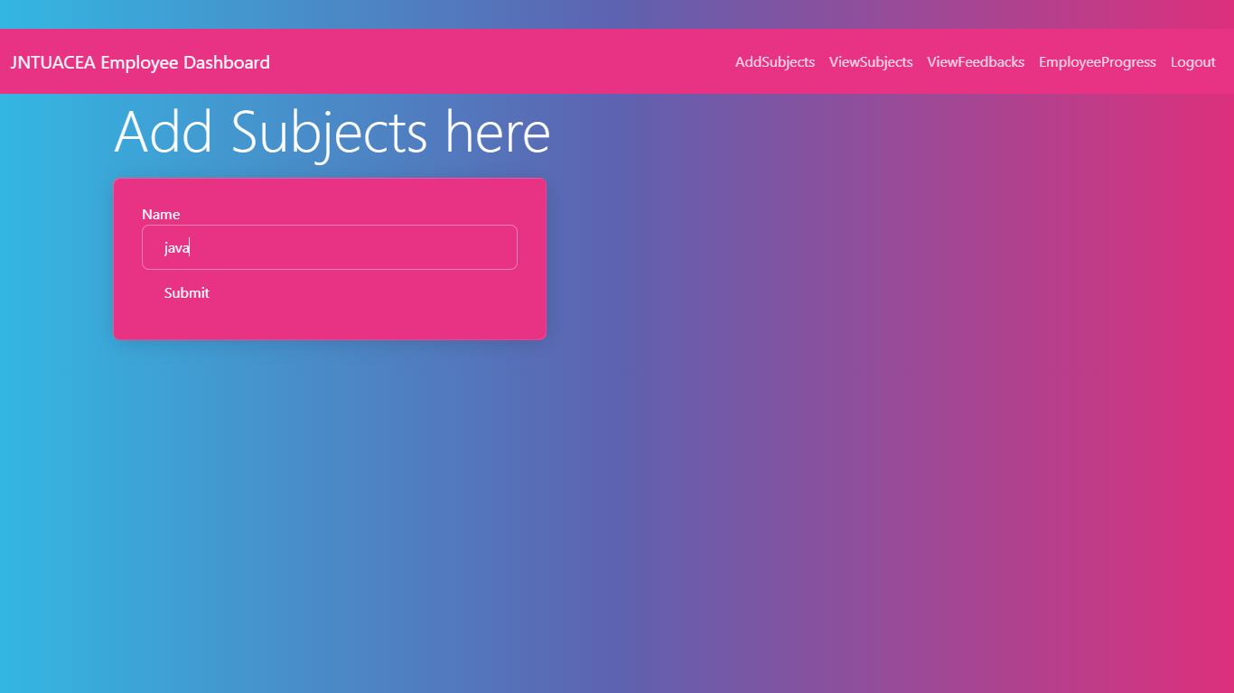

**ADD SUBJECTS:**  In this page hod can add subjects

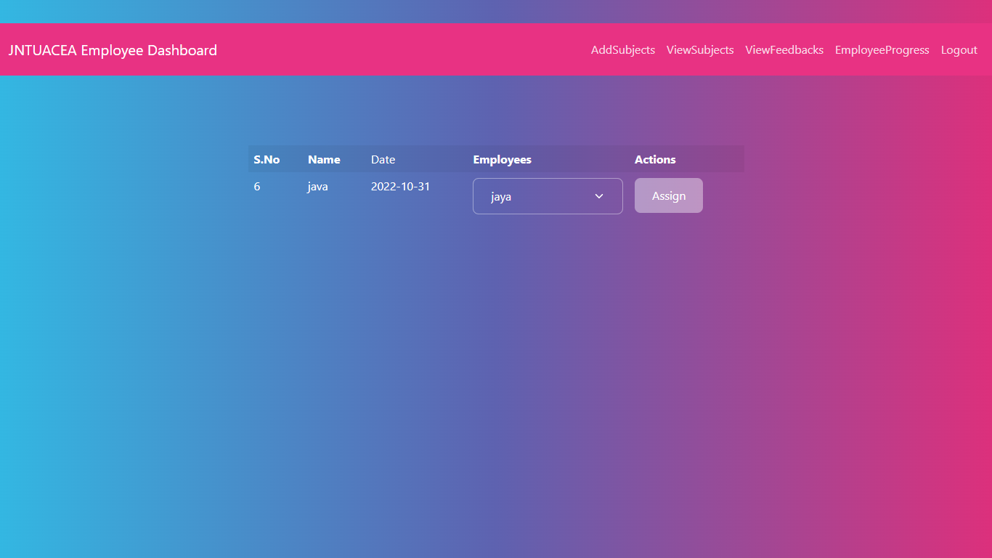

**ASSIGN SUBJECTS :**  In this page hod can assign subjects for a particular employee.

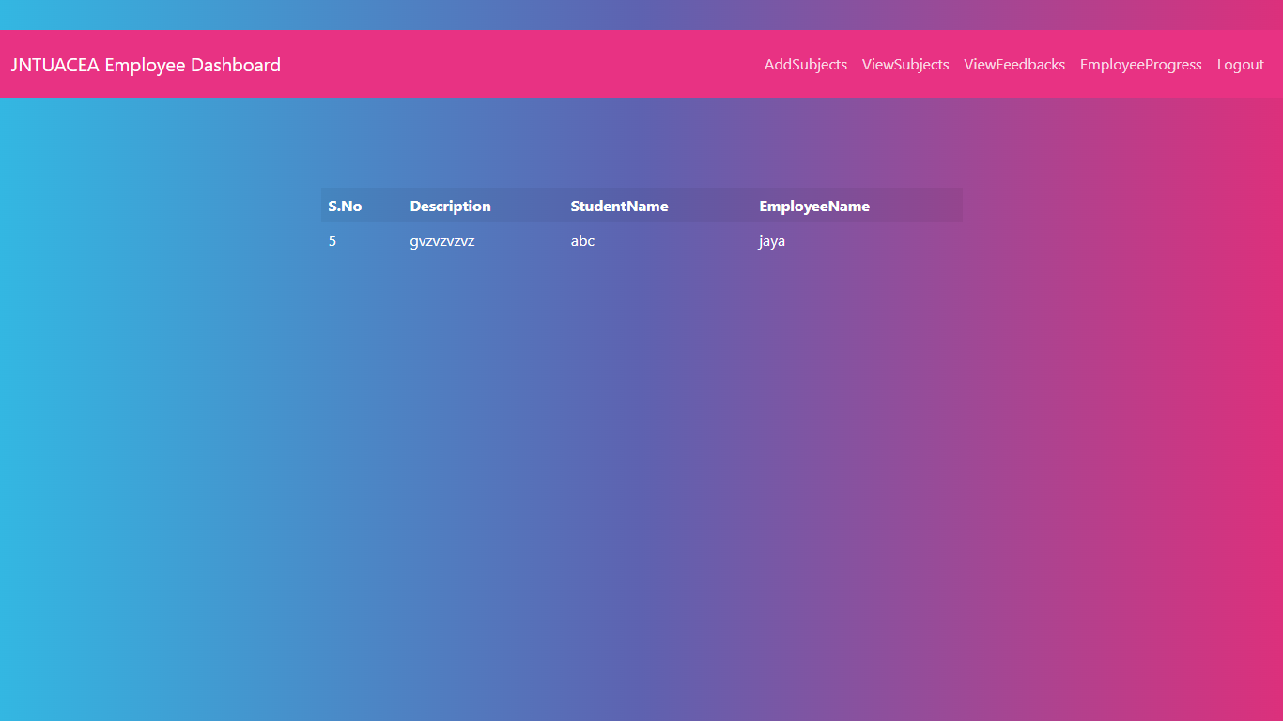

**VIEW FEEDBACKS:**  In this page hod can view feedbacks given by students for employees.

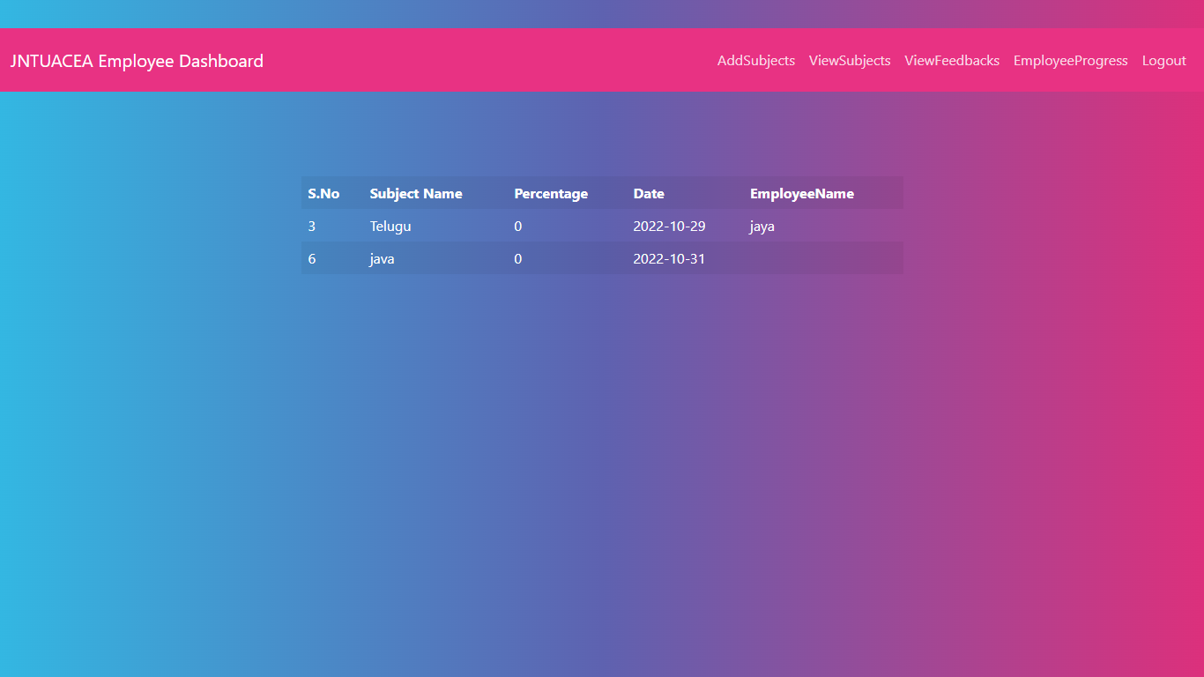

**PROGRESS:** In this page hod can view the progress given by employee.

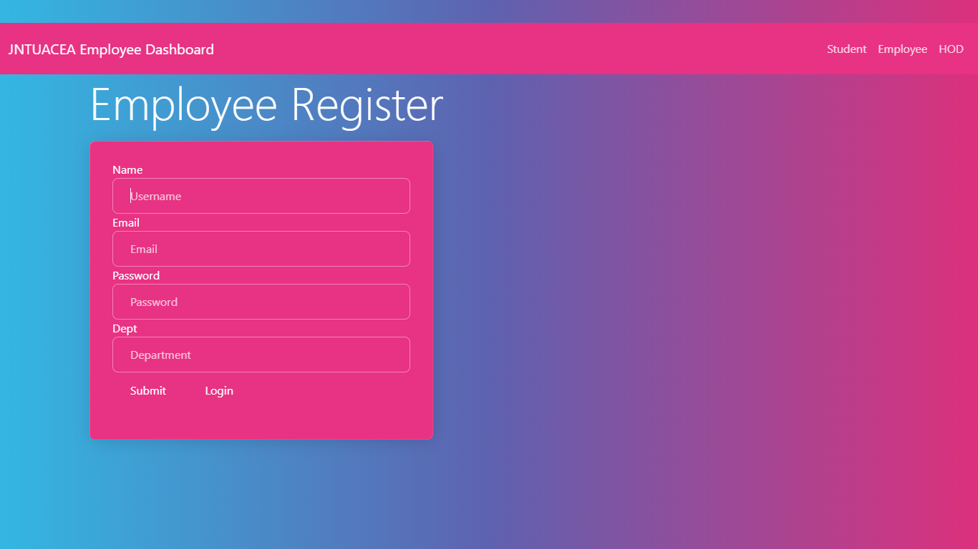

**EMPPLOYEE REGISTER :**  In this page employee can register here.

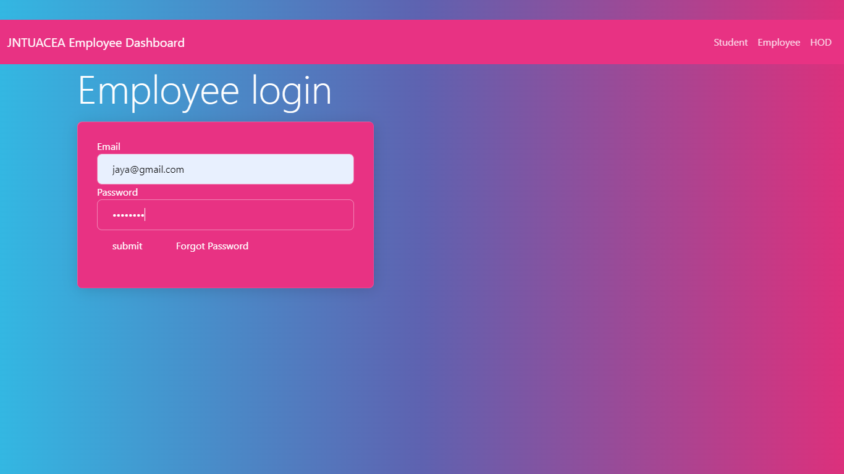

**EMPLOYEE LOGIN:**  In this page employee can login here with their login details

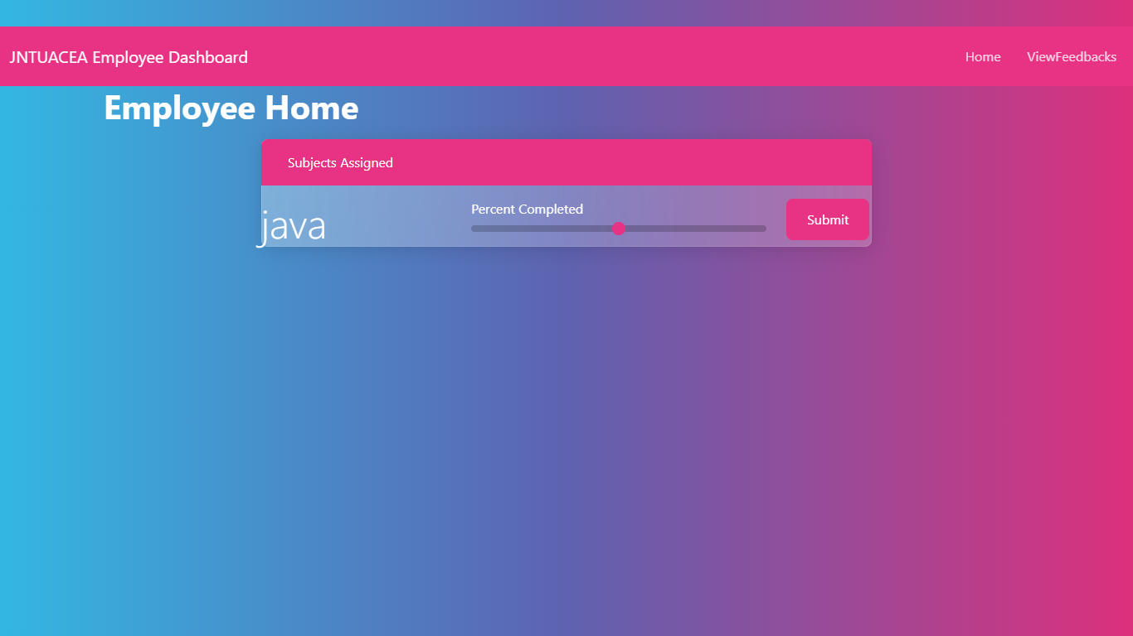

**EMPLOYEE HOME :** Employee can complete the work given by hod and along with view feedbacks given by the students.

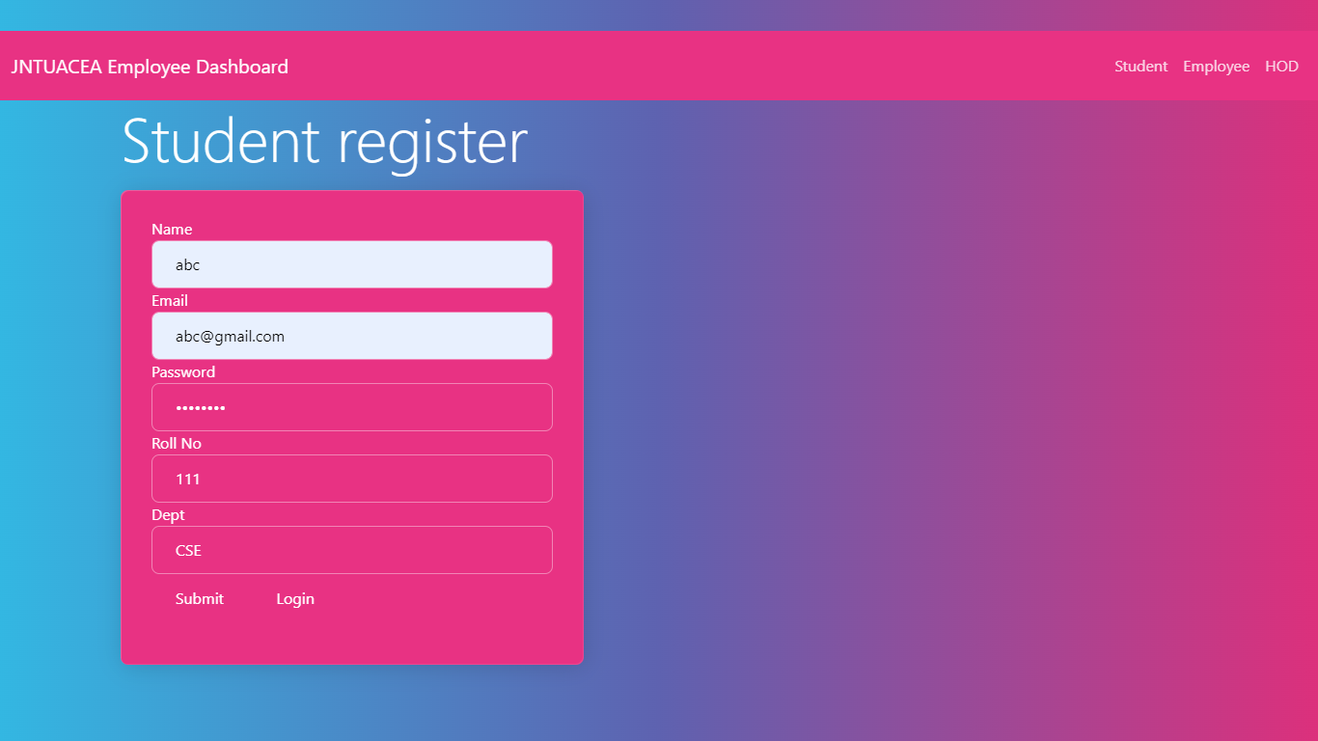

**STUDENT REGISTER:**  In this page student can register with required details

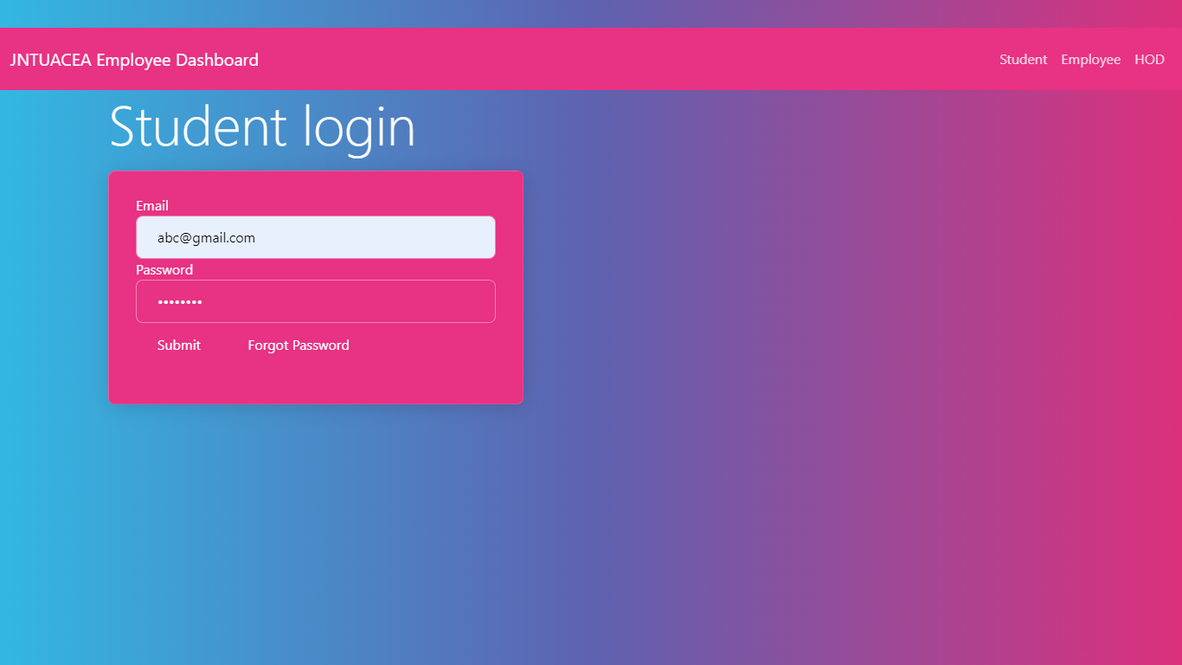

**STUDENT LOGIN :** In this page student can login with their credentials.

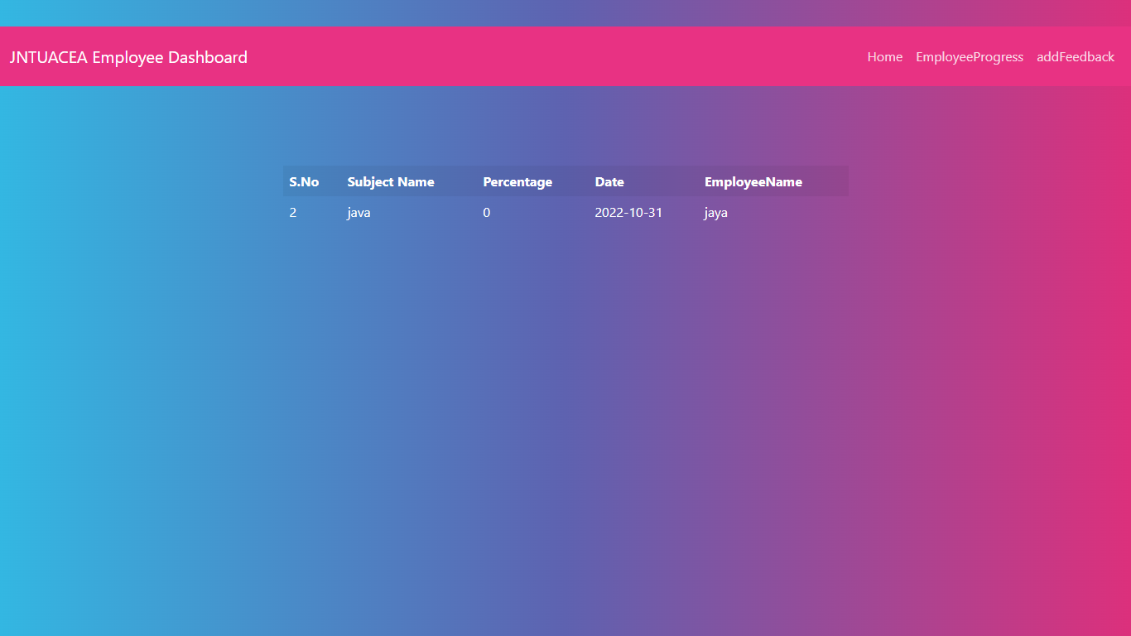

**VIEW PROGRESS :**  In this page student can view employee progress.

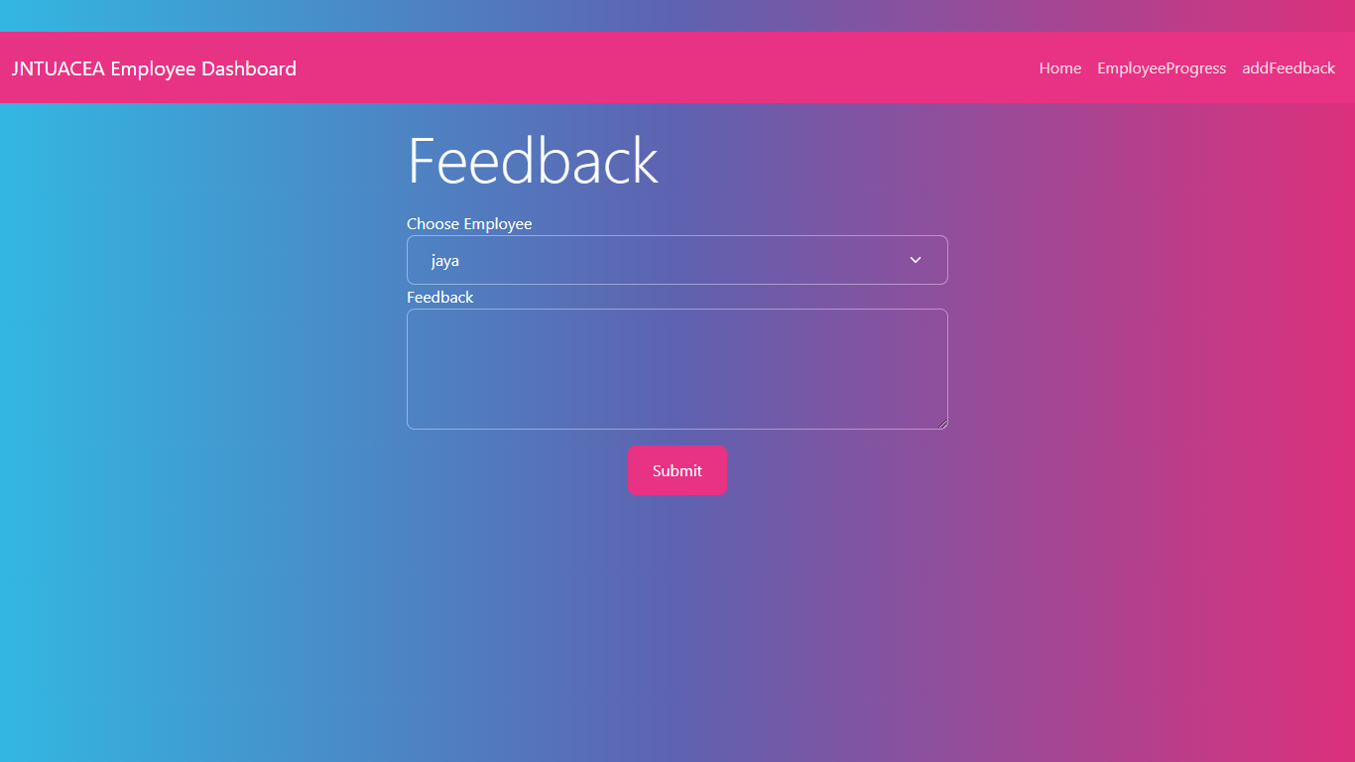

**FEEDBACK:**  In this page student can give feedback with a particular employee.

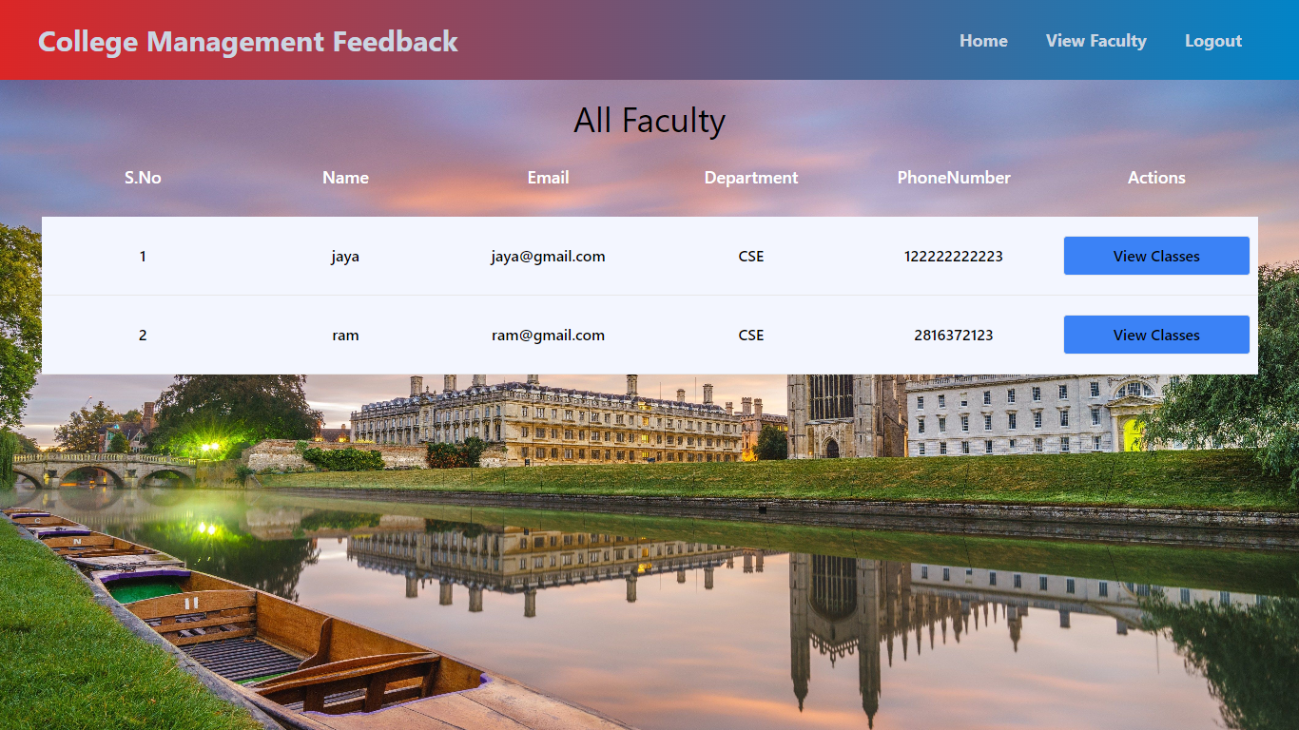

**View Faculty:**  Here student can view all faculty. And view their classes.

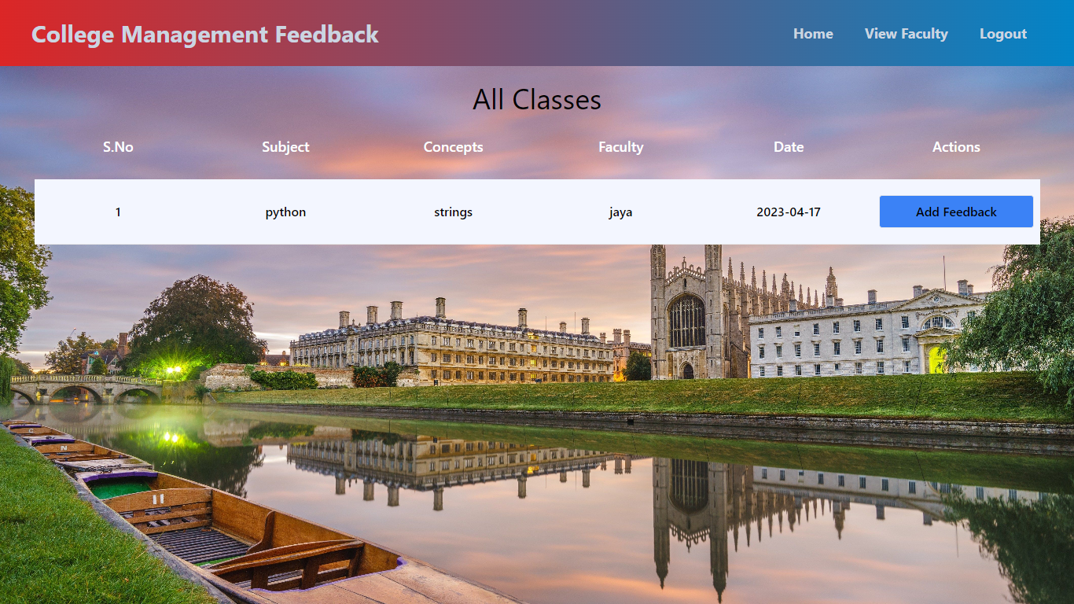

**View classes :**  Here student can view all classes and add feed back.

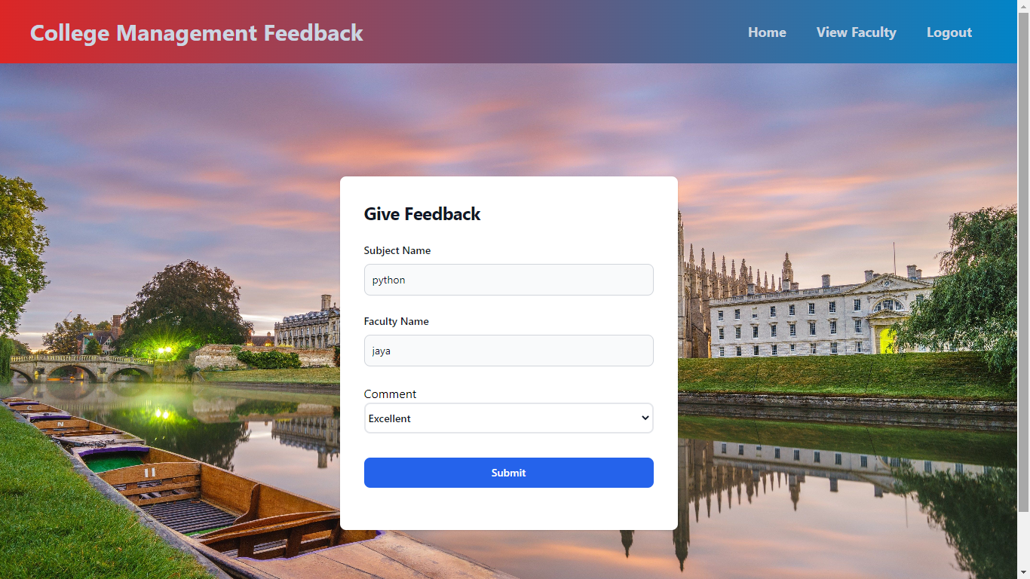

**Give feedback :**  Here student can give his feedback.

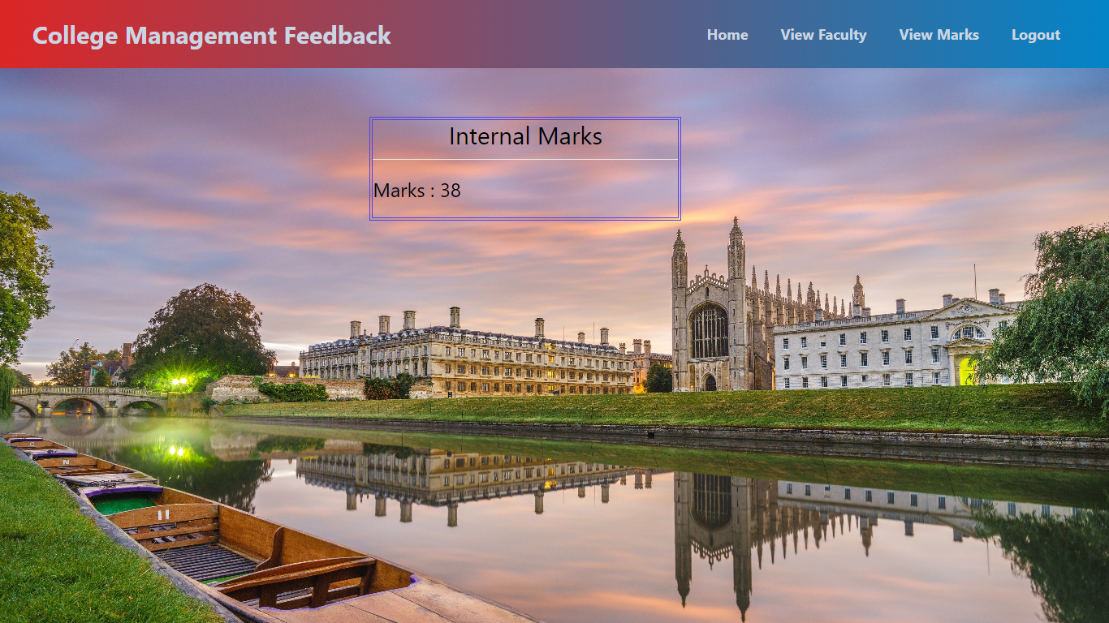

**View Marks :**  Here student can view his internal marks.

**7. JAVA ENVIRONMENT**

**7.1 Software Installation**

This Java Development Kit(JDK) allows you to code and run Java programs. It's possible that you install multiple JDK versions on the same PC. But It’s recommended that you install only latest version.

## How to install Java for Windows

Following are the steps for JDK 8 free download for 32 bit or JDK 8 download 64 bit and installation

**Step 1)** Go to [link](https://www.oracle.com/java/technologies/javase-downloads.html). Click on JDK Download for Java

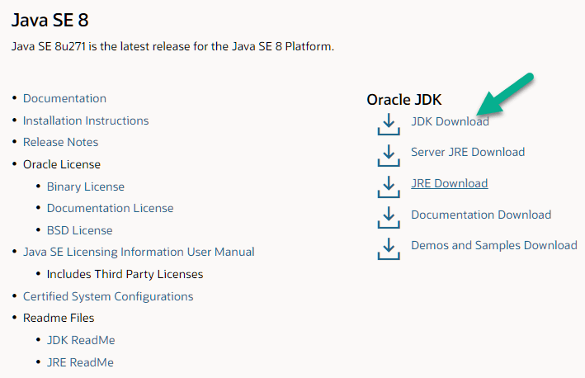

**Step 2)** Next,

1. Accept License Agreement
2. Download Java 8 JDK for your version 32 bit or JDK 8 download for windows 10 64 bit.

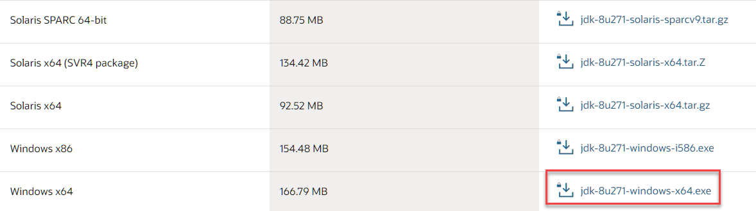

**Step 3)** when you click on the Installation link the popup will be open. Click on I reviewed and accept the Oracle Technology Network License Agreement for Oracle Java SE and you will be redirected to the login page. If you don't have an oracle account you can easily sign up by adding basics details of yours.

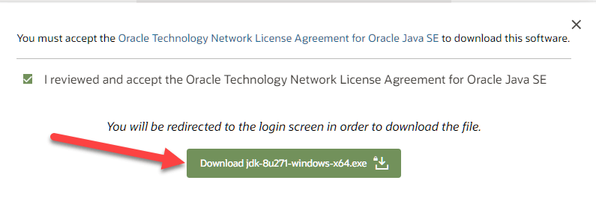

**Step 4)** Once the Java JDK 8 download is complete, run the exe for install JDK. Click Next

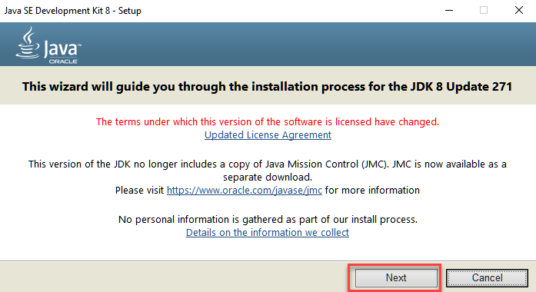

**Step 5)** Select the PATH to install Java in Windows and click next.

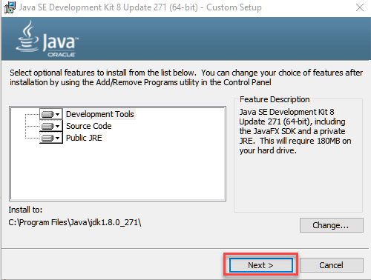

**Step 6)** Once you install Java in windows, click close

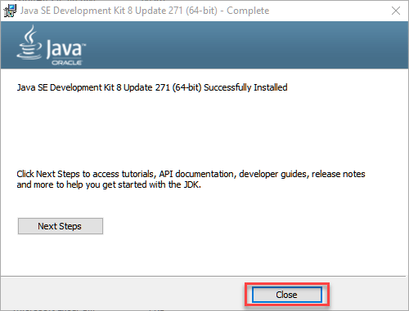

## How to set Environment Variables in Java: Path and Class path

The PATH variable gives the location of executable like javac, java etc. It is possible to run a program without specifying the PATH but you will need to give full path of executable like **C:\Program Files\Java\jdk-13.0.1\bin\javac A.java** instead of simple **javac A.java**

The CLASSPATH variable gives location of the Library Files.

Let's look into the steps to set the PATH and CLASSPATH

**Step 1)** Right Click on the My Computer and Select the properties

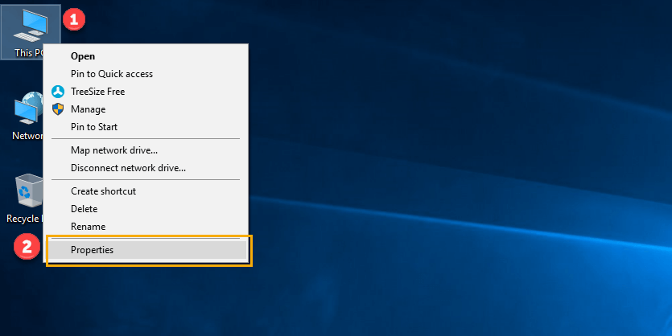

**Step 2)** Click on advanced system settings

**Step 3)** Click on Environment Variables

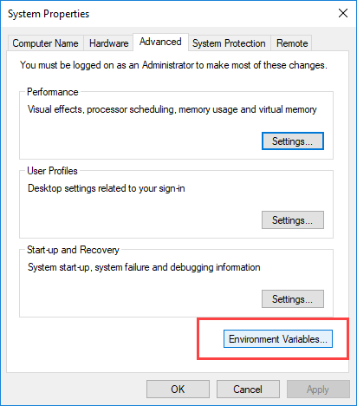

**Step 4)** Click on new Button of User variables

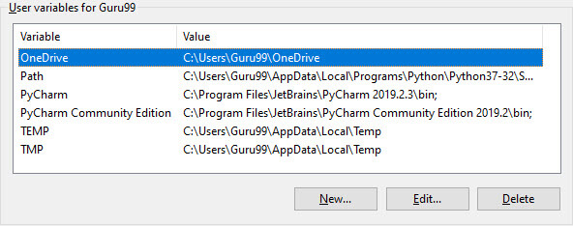

**Step 5)** Type PATH in the Variable name.

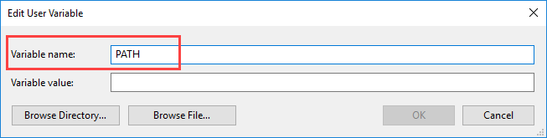

**Step 6)** Copy the path of bin folder which is installed in JDK folder.

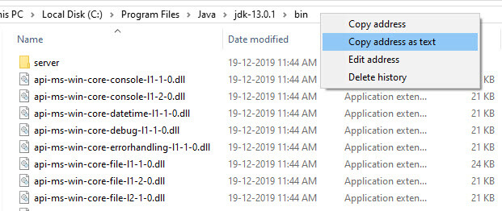

**Step 7)** Paste Path of bin folder in Variable value and click on OK Button.

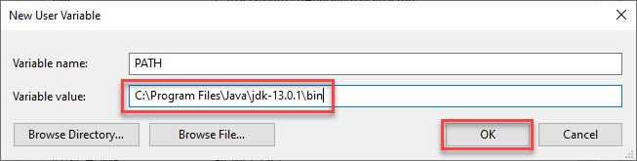

**Note:** In case you already have a PATH variable created in your PC, edit the PATH variable to

PATH = <JDK installation directory>\bin;%PATH%;

Here, %PATH% appends the existing path variable to our new value

**Step 8)**You can follow a similar process to set CLASSPATH.

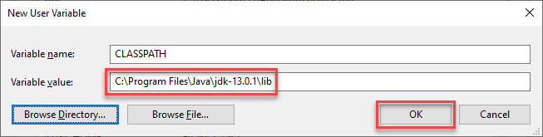

**Note:** In case you java installation does not work after installation, change classpath to

CLASSPATH = <JDK installation directory>\lib\tools.jar;

**Step 9)** Click on OK button

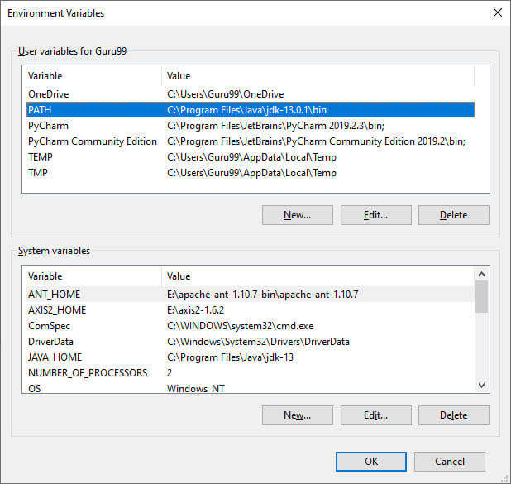

**Step 10)** Go to command prompt and type javac commands.

If you see a screen like below, Java is installed.

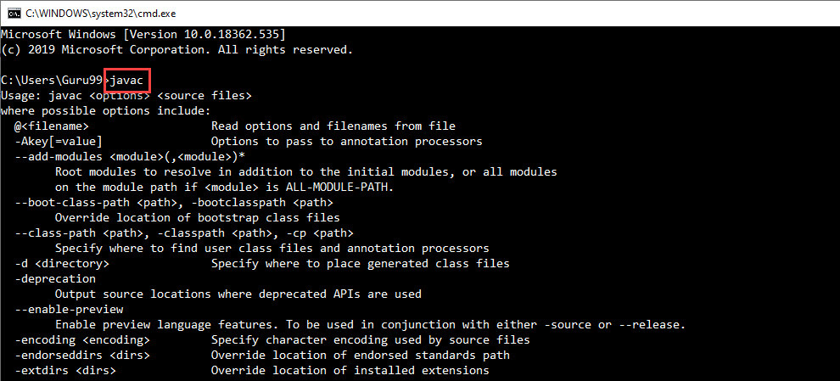

**INSTALLING JAVA AND INTELLIJ IDEA**

**Installing java:**

This Java Development Kit(JDK) allows you to code and run Java programs. It's possible that you install multiple JDK versions on the same PC. But It’s recommended that you install only latest version.

## How to install Java for Windows

Following are the steps for JDK 8 free download for 32 bit or JDK 8 download 64 bit and installation

**Step 1)** Go to [link](https://www.oracle.com/java/technologies/javase-downloads.html). Click on JDK Download for Java



**Step 2)** Next,

1. Accept License Agreement
2. Download Java 8 JDK for your version 32 bit or JDK 8 download for windows 10 64 bit.



**Step 3)** when you click on the Installation link the popup will be open. Click on I reviewed and accept the Oracle Technology Network License Agreement for Oracle Java SE and you will be redirected to the login page. If you don't have an oracle account you can easily sign up by adding basics details of yours.



**Step 4)** once the Java JDK 8 download is complete, run the exe for install JDK. Click Next



**Step 5)** Select the PATH to install Java in Windows and click next.



**Step 6)** Once you install Java in windows, click close



## How to set Environment Variables in Java: Path and Class path

The PATH variable gives the location of executable like javac, java etc. It is possible to run a program without specifying the PATH but you will need to give full path of executable like **C:\Program Files\Java\jdk-13.0.1\bin\javac A.java** instead of simple **javac A.java**

The CLASSPATH variable gives location of the Library Files.

Let's look into the steps to set the PATH and CLASSPATH

**Step 1)** Right Click on the My Computer and Select the properties



**Step 2)** Click on advanced system settings

**Step 3)** Click on Environment Variables



**Step 4)** Click on new Button of User variables



**Step 5)** Type PATH in the Variable name.



**Step 6)** Copy the path of bin folder which is installed in JDK folder.



**Step 7)** Paste Path of bin folder in Variable value and click on OK Button.



**Note:** In case you already have a PATH variable created in your PC, edit the PATH variable to

PATH = <JDK installation directory>\bin;%PATH%;

Here, %PATH% appends the existing path variable to our new value

**Step 8)**You can follow a similar process to set CLASSPATH.



**Note:** In case you java installation does not work after installation, change classpath to

CLASSPATH = <JDK installation directory>\lib\tools.jar;

**Step 9)** Click on OK button



**Step 10)** Go to command prompt and type javas commands.

If you see a screen like below, Java is installed.



Installing intellij idea:

1. To download Intellij visit the website https://www.jetbrains.com/idea/download/#section=windows and Click the "DOWNLOAD" link under the Community Section.

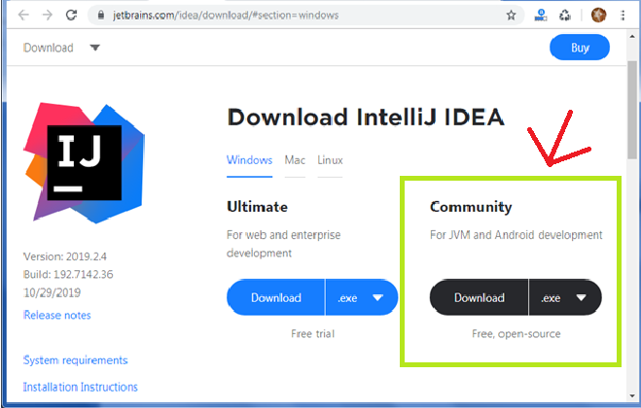

1. Once the download is complete, run the exe for install Intellij. The setup wizard should have started. Click “Next”.
2. On the next screen, Change the installation path if required. Click “Next”.
3. On the next screen, you can create a desktop shortcut if you want and click on “Next”.
4. Choose the start menu folder. Keep selected Jet Brains and click on “Install”.
5. Wait for the installation to finish.
6. Once installation finished, you should receive a message screen that Intellij is installed. If you want to go ahead and run it, click the “Run Intellij Community Edition” box first and click “Finish”.
7. After you click on "Finish," the Following screen will appear.

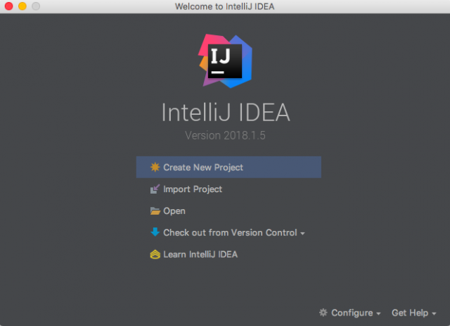

**Installing visual studio code**

Steps to installing visual studio code:

Step 1: Head over to the website <https://code.visualstudio.com/download>

Step2:choose the option as per your choice.

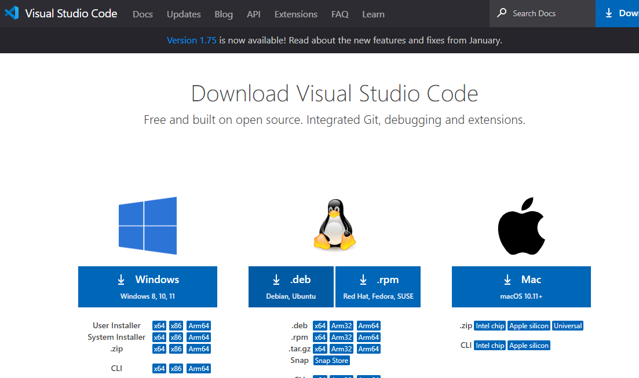

Step 3: Once download completed,open it and your screen will appear like this

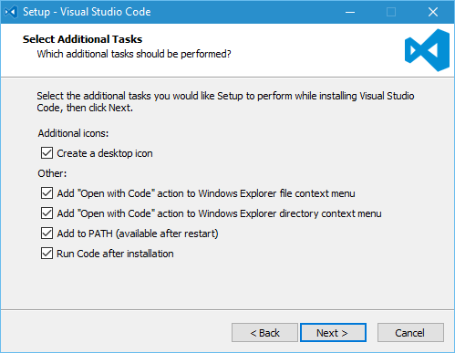

Step 4: click next until you saw the below page

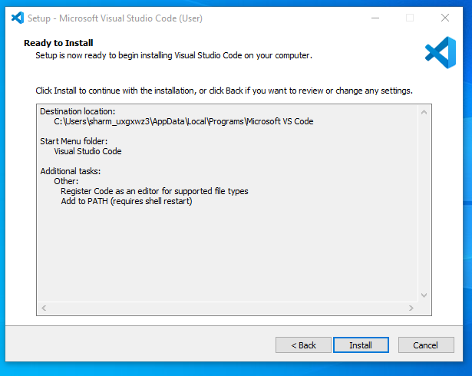

Step 4: After installation your screen will appear like this ,click finish and continue.

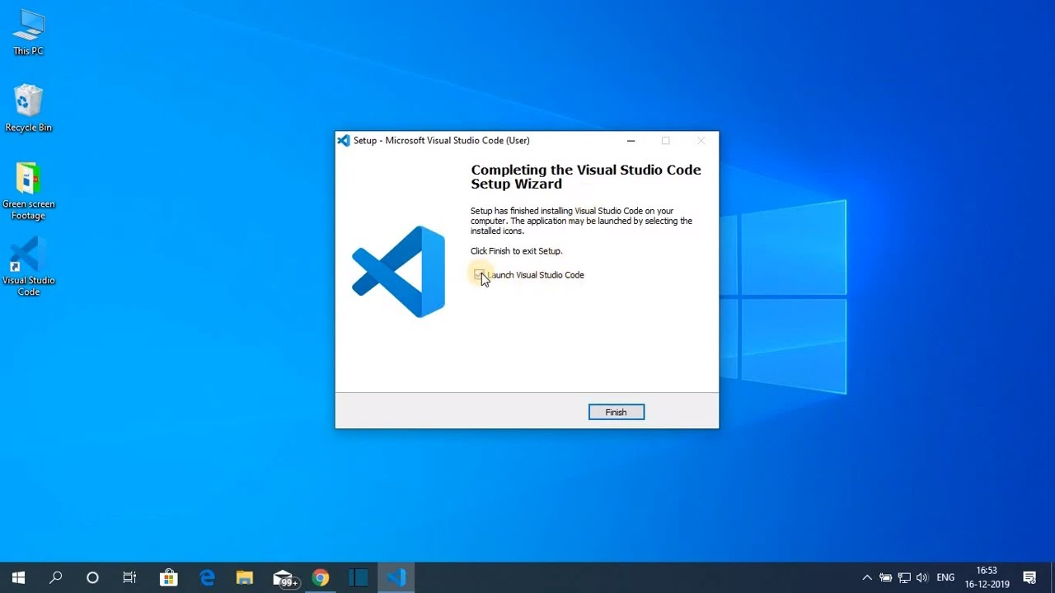

**Installing mysql**

Step 1: Go to the official website <https://www.mysql.com/downloads/>

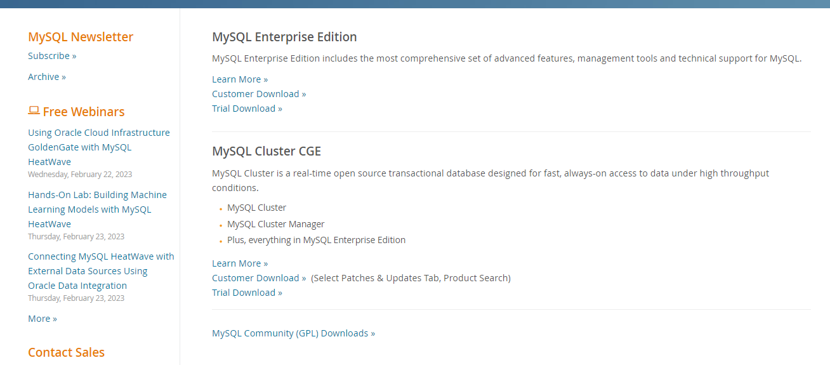

Step 2: click on the Mysql commu community downloads

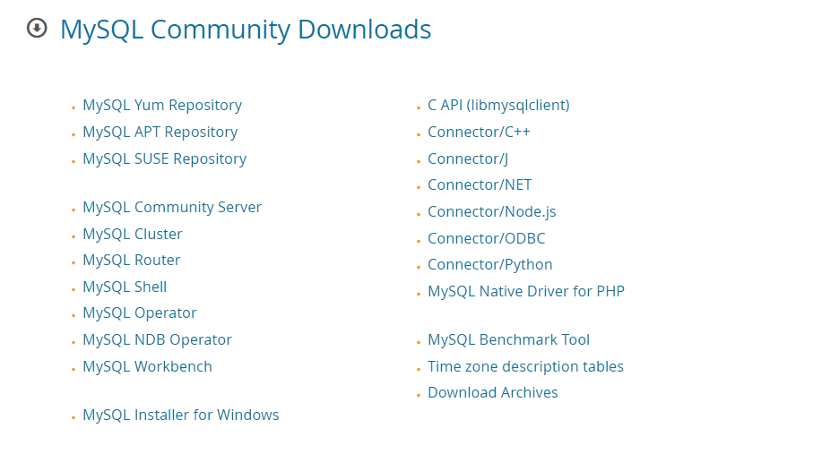

Step 3: click on Mysql installer for windows.

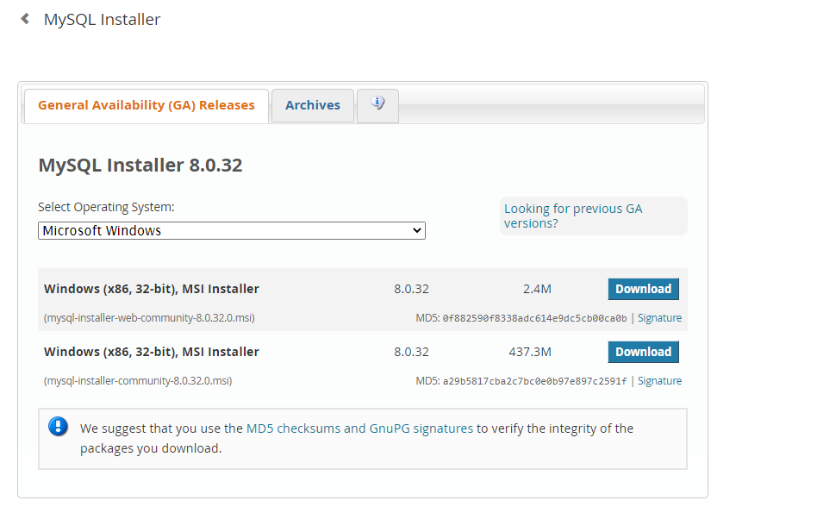

Step 4:click on the download at the bottom.

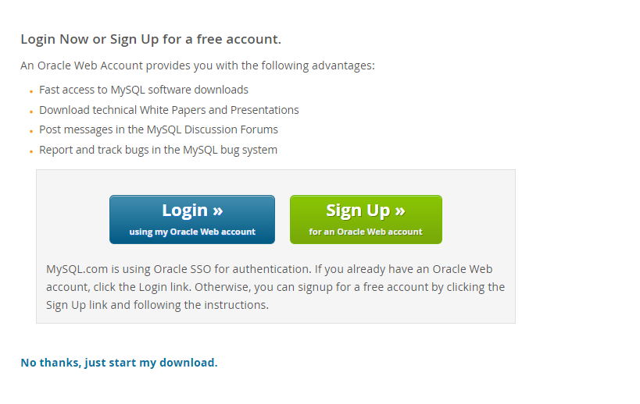

Step 5:click on No thanks, just start my download. Mysql will start downloading.After download is completed,open it and your screen will appear like this and choose custom from the following options and click next.

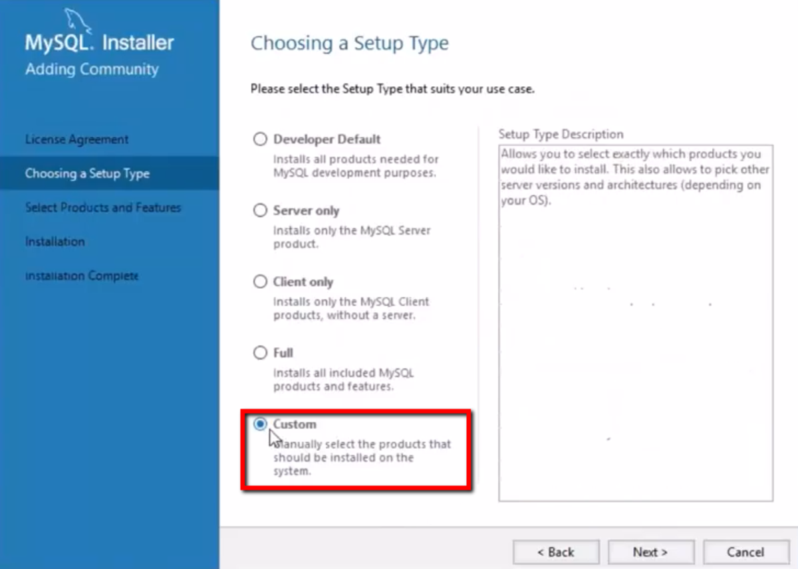

Step 6: choose server,workbench and shell and click arrow mark to add the following packages and click next.

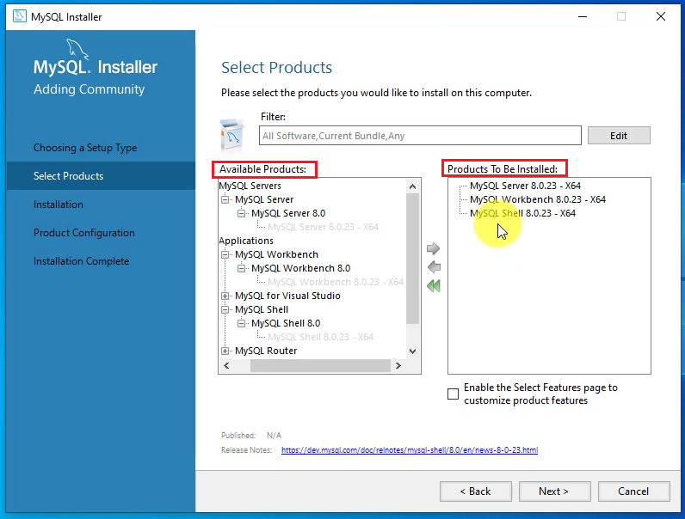

Step 7: click on execute and your download will be started.

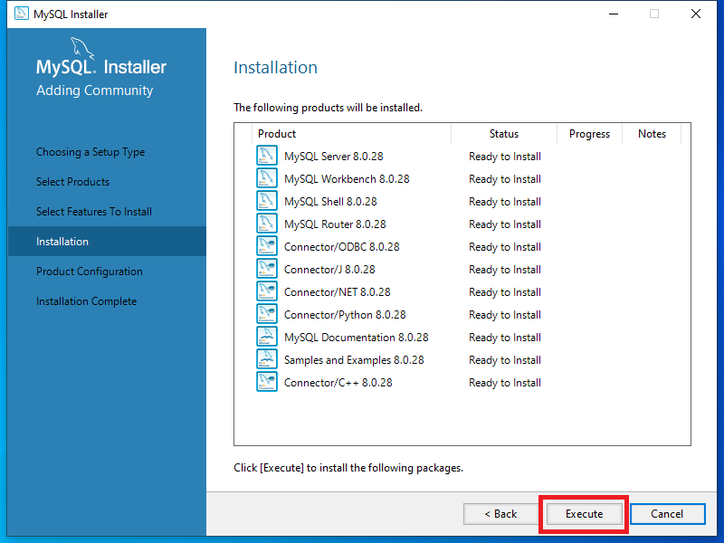

Step 8: Once completed your screen will appear like this.

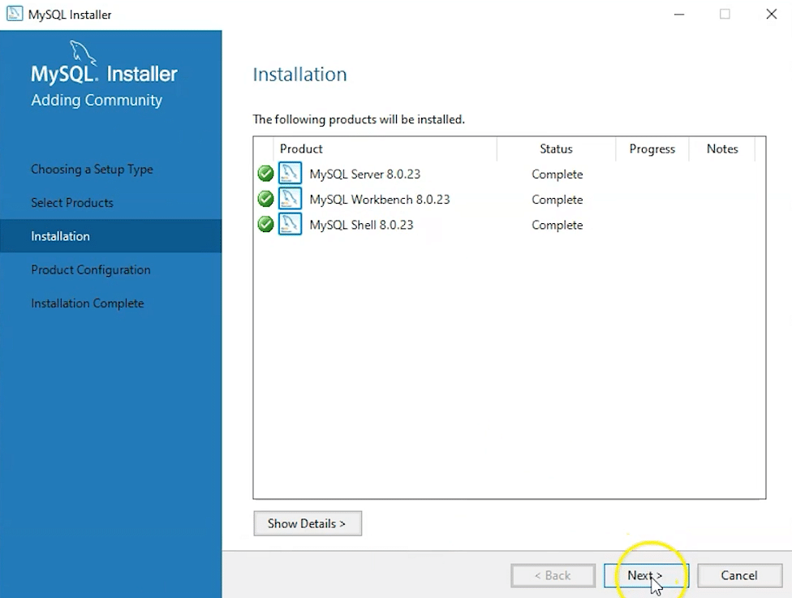

Step 9: click next and set the port number as 3306 .

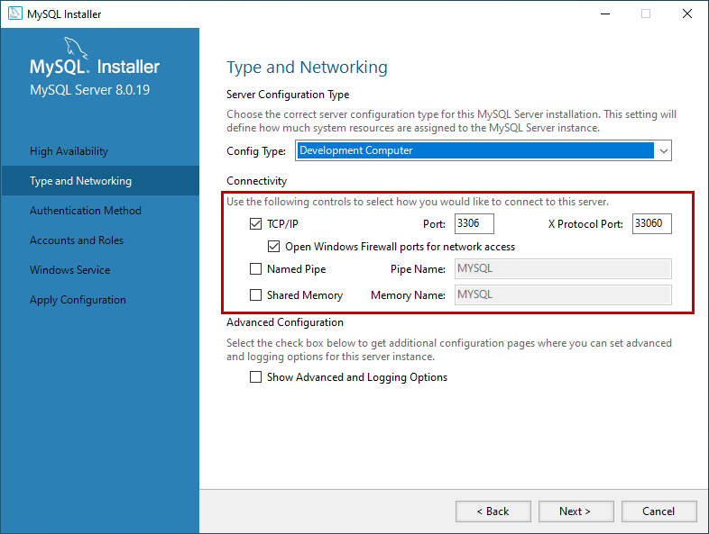

Step 10: select use strong password and click next.

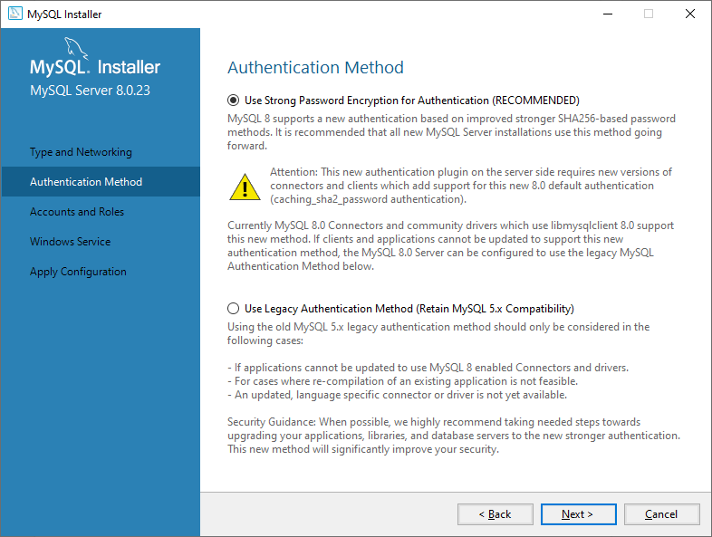

Step 11: set password and click next.

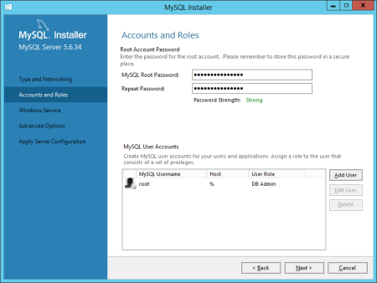

Step 12: set Mysql service name as MYSQL80.

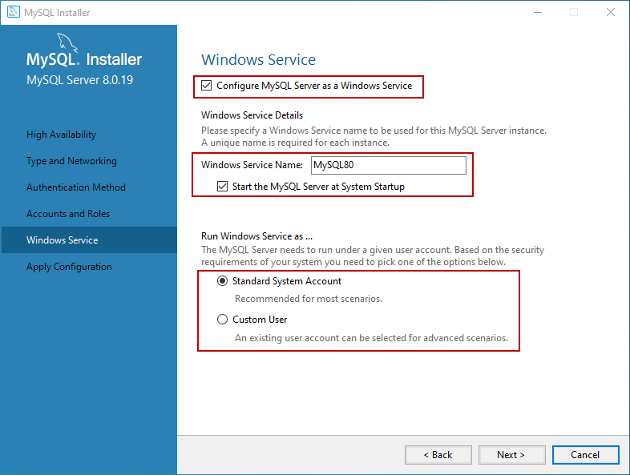

Step 13: select default and click on next.

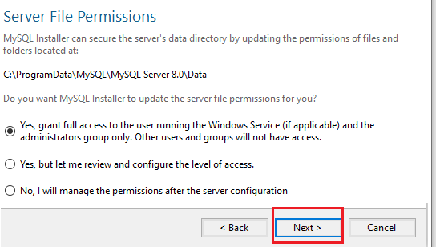

Step 14: click on execute and it will finish executing.

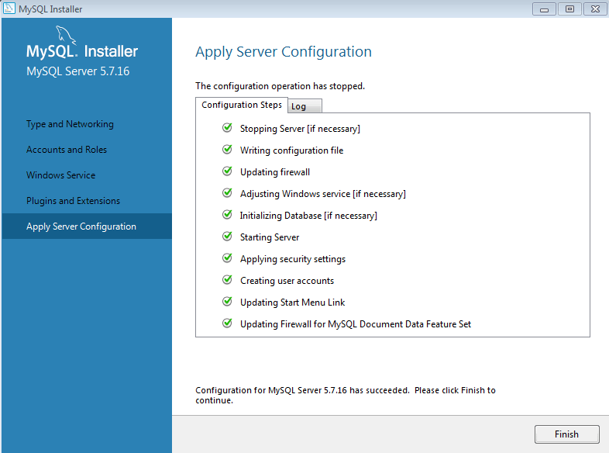

Step 15: click on next.

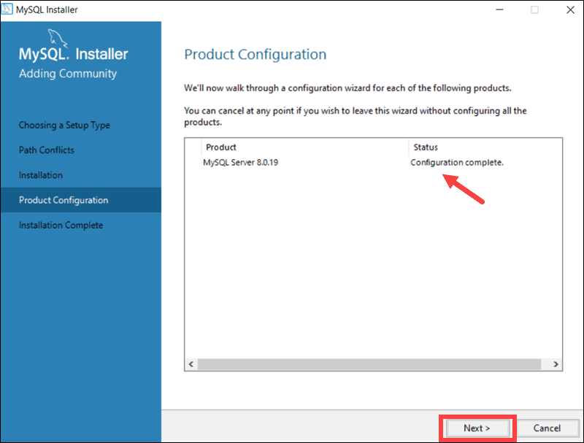

Step 16:click on finish.

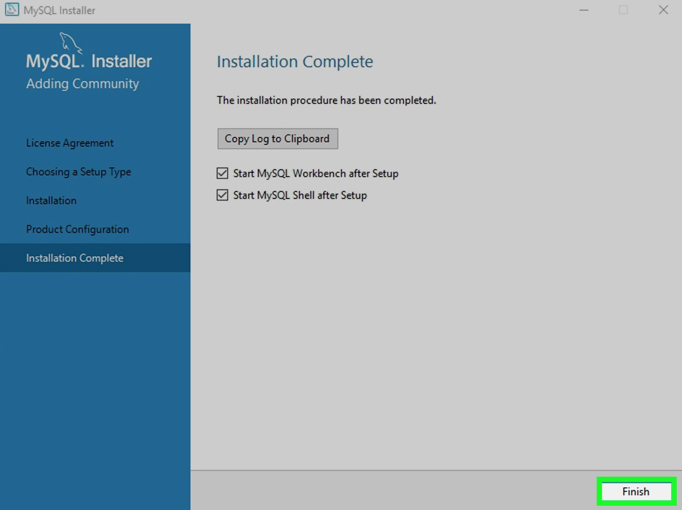

**8. SYSTEM STUDY AND TESTING**

**8.1 Feasibility Study**

The feasibility of the project is analysed in this phase and business proposal is put forth with a very general plan for the project and some cost estimates. During system analysis the feasibility study of the proposed system is to be carried out. This is to ensure that the proposed system is not a burden to the company. For feasibility analysis, some understanding of the major requirements for the system is essential.

Three key considerations involved in the feasibility analysis are

* Economical feasibility
* Technical feasibility
* Social feasibility

**Economical Feasibility**

This study is carried out to check the economic impact that the system will have on the organization. The amount of fund that the company can pour into the research and development of the system is limited. The expenditures must be justified. Thus the developed system as well within the budget and this was achieved because most of the technologies used are freely available. Only the customized products had to be purchased.

### **Technical Feasibility**

This study is carried out to check the technical feasibility, that is, the technical requirements of the system. Any system developed must not have a high demand on the available technical resources. This will lead to high demands on the available technical resources. This will lead to high demands being placed on the client. The developed system must have a modest requirement, as only minimal or null changes are required for implementing this system.

**Social Feasibility**

The aspect of study is to check the level of acceptance of the system by the user. This includes the process of training the user to use the system efficiently. The user must not feel threatened by the system, instead must accept it as a necessity. The level of acceptance by the users solely depends on the methods that are employed to educate the user about the system and to make him familiar with it. His level of confidence must be raised so that he is also able to make some constructive criticism, which is welcomed, as he is the final user of the system.

### **System Testing**

The purpose of testing is to discover errors. Testing is the process of trying to discover every conceivable fault or weakness in a work product. It provides a way to check the functionality of components, sub-assemblies, assemblies and/or a finished product It is the process of exercising software with the intent of ensuring that the

Software system meets its requirements and user expectations and does not fail in an unacceptable manner. There are various types of test. Each test type addresses a specific testing requirement.

**8.2 Types of Tests**

**8.2.1 Unit testing**

Unit testing involves the design of test cases that validate that the internal program logic is functioning properly, and that program inputs produce valid outputs. All decision branches and internal code flow should be validated. It is the testing of individual software units of the application .it is done after the completion of an individual unit before integration. This is a structural testing, that relies on knowledge of its construction and is invasive. Unit tests perform basic tests at component level and test a specific business process, application, and/or system configuration. Unit tests ensure that each unique path of a business process performs accurately to the documented specifications and contains clearly defined inputs and expected results.

**8.2.2 Integration testing**

Integration tests are designed to test integrated software components to determine if they actually run as one program. Testing is event driven and is more concerned with the basic outcome of screens or fields. Integration tests demonstrate that although the components were individually satisfaction, as shown by successfully unit testing, the combination of components is correct and consistent. Integration testing is specifically aimed at exposing the problems that arise from the combination of components.

Software integration testing is the incremental integration testing of two or more integrated software components on a single platform to produce failures caused by interface defects.

The task of the integration test is to check that components or software applications, e.g. components in a software system or – one step up – software applications at the company level – interact without error.

**Test Results:** All the test cases mentioned above passed successfully. No defects encountered.

**Acceptance Testing**

User Acceptance Testing is a critical phase of any project and requires significant participation by the end user. It also ensures that the system meets the functional requirements.

**Test Results:** All the test cases mentioned above passed successfully. No defects encountered.

**8.2.3 Functional testing**

Functional tests provide systematic demonstrations that functions tested are available as specified by the business and technical requirements, system documentation, and user manuals.

Functional testing is centered on the following items:

Valid Input : identified classes of valid input must be accepted.

Invalid Input : identified classes of invalid input must be rejected.

Functions : identified functions must be exercised.

Output : identified classes of application outputs must be exercised.

Systems/Procedures: interfacing systems or procedures must be invoked.

Organization and preparation of functional tests is focused on requirements, key functions, or special test cases. In addition, systematic coverage pertaining to identify Business process flows; data fields, predefined processes, and successive processes must be considered for testing. Before functional testing is complete, additional tests are identified and the effective value of current tests is determined.

**9.2.4 White Box Testing**

White Box Testing is a testing in which in which the software tester has knowledge of the inner workings, structure and language of the software, or at least its purpose. It is purpose. It is used to test areas that cannot be reached from a black box level.

**9.2.5 Black Box Testing**

Black Box Testing is testing the software without any knowledge of the inner workings, structure or language of the module being tested. Black box tests, as most other kinds of tests, must be written from a definitive source document, such as specification or requirements document, such as specification or requirements document. It is a testing in which the software under test is treated, as a black box .you cannot “see” into it. The test provides inputs and responds to outputs without considering how the software works.

**Test objectives**

* All field entries must work properly.
* Pages must be activated from the identified link.
* The entry screen, messages and responses must not be delayed.

**Features to be tested**

* Verify that the entries are of the correct format
* No duplicate entries should be allowed
* All links should take the user to the correct page.

1. **CONCLUSION**

Finally we conclude that our project student feedback system is an efficient system to take the feedback from the students and generate report for each faculty, consolidation report for the entire class. These reports help the management and faculty to effectively teach students. These systems is tested on different test cases and showed positive result.

**FUTURE ENHANCEMENT**

It is quite obvious that tomorrow’s feedback system will tend to rely more on technology. With the introduction of the next generation apps and online services, exam details is going to get further accessible and enjoyable.

Automated scheduling: One enhancement could be to incorporate automated scheduling functionality into the system, so that it giving feedback to staff members based on their performance and acedmics. This would save time and reduce errors associated with manual scheduling.

Mobile access: It may also be useful to add mobile access to the system, allowing invigilators to access their duty schedules, exam details, and other relevant information from their mobile devices. This would improve convenience and reduce the likelihood of miscommunication.

**11.REFERANCES**

[1] C. Emery, Tracy R. Kramer and Robert G. Tian, Return to academics standards: a critique of student evaluations of teaching effectiveness, Quality Assurance in Education, vol. II, no. 1, pp. 37-46, 2003.

[2] J. T. E. Richardson, "Instruments for obtaining student feedback: a review of the literature", Assessment & Evaluation in Higher Education, vol. 30, no. 4, pp. 387-415, 2005.

[3] A. M. Zapalska, M. N. Bugaj, F. Flanegin and D. Rudd, "Student feedback on distance learning with the use of WebCT", Computers in Higher Education Economics Review, vol. 16, no. 1, pp. 10-14, 2004.

[4] T. Zarraonandia, P. Díaz, Á. Montero, I. Aedo and T. Onorati, "Using a Google Glass-based Classroom Feedback System to improve students to teacher communication", IEEE Access, vol. 7, pp. 16837-16846, 2019.

[5] V. Rivera-Pelayo, J. Munk, V. Zacharias and S. Braun, "Live interest meter: learning from quantified feedback in mass lectures", Proceedings of the Third International Conference on Learning Analytics and Knowledge, pp. 23-27, 2013.

[6] R. Anderson, T. VanDeGrift, S. A. Wolfman, K. Yasuhara and R. Anderson, "Interaction patterns with a classroom feedback system: making time for feedback" in CHI’03 Extended Abstracts on Human Factors in Computing Systems, pp. 880-881, 2003.